Building A New Home One Gift At A Time--Matching Grant Opportunity to Raise $50,000

40 YEARS! That's right--an incredible 40 years ago this amazing group of parents, families and friends of those with intellectual and developmental disabilities came together to address their concerns for the future of their loved ones. Simply put, it was decided that what was most needed was permanent care in the best of residential settings. As a result, a STAR is born!
There have been many challenges during the past 40 years--but the rewards have been even greater. STAR 1/Ben Scalabrini House and STAR 2/Caribou House are places filled with love, joy, laughter, security, growth--not just addresses, but places our residents call home.
But to quote Bob Dylan, "The Times They Are a-Changing."

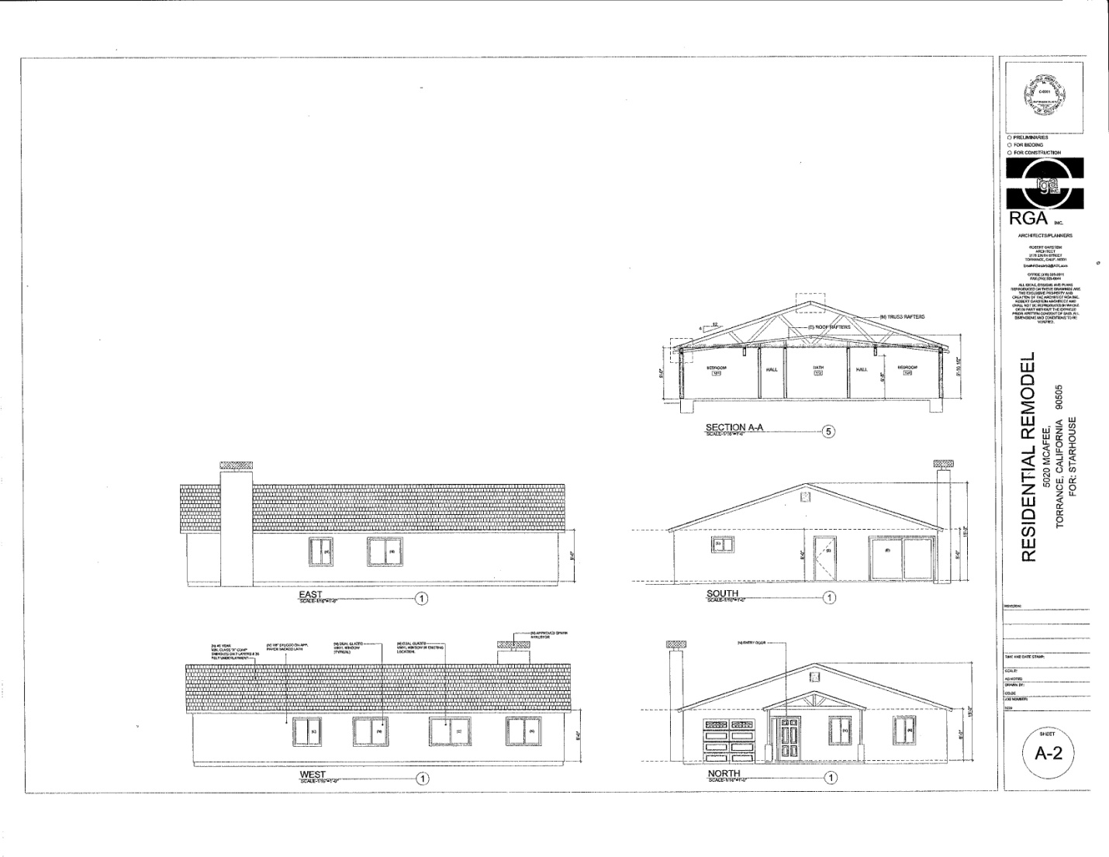
The life expectancy among members of the population we serve has improved considerably. As an example, the average life span of individuals affected by Down Syndrome has increased from 9 years in the 1920s to 65 years or greater in the 1990s. As these individuals begin to live longer lives, the question of how to guarantee that they are provided with the proper support services to ensure empowerment, respect, dignity, and happiness in their "golden years" becomes relevant. The 2015 Project at New York State's Department of Aging estimates that approximately 500,000 elderly in the U.S. are developmentally disabled, and that this figure can be expected to double by 2030.
The combination of a primary disability with the declines of aging places the developmentally disabled person in a special category of vulnerability; and they typically experience the effects at an earlier age. There are few programs designed to deal exclusively with the aging developmentally disabled population and the increased care required by these individuals. Most programs and services offered are geared toward children and young adults. Due to the fact that the needs of the intellectually disabled population can be much greater than the needs of the non-developmentally disabled, traditional nursing facilities are simply not capable of accommodating the increased level of care that may sometimes be required. Very few agencies currently alter their service structure for aging clients in ways that help families and care-providers in making the necessary accommodations for transitions.
Those of us at STAR experienced first-hand the effects of aging on our beloved resident, Larry, who dealt with the challenges of a debilitating disease with the help of our devoted staff and friends. Sharing this journey with him left no doubt that there is a demand for disabled senior services, and it increases with each passing day.
Currently, STAR is limited to the extent of the services we can provide. It is with these issues and facts in mind that STAR envisions the development of the third STAR home to address the needs of our residents as they "age out" of traditional services and require more specialized care. It is our mission to bridge the gap between adult and senior residential services for the intellectually and developmentally disabled, and to ensure that our residents have access to quality medical treatment, focused personal care, and anything else that may be compulsory as a facet of their aging.
Your generosity has brought us a long way since 1973. Thanks to our supporters, STAR was able to purchase a third home in November 2012. But this project has only just begun. We are in the planning and design stages. With an urgent need to break ground soon, we ask for your help to raise the financial resources we need to make this dream a reality.
The Board Members of the John Gogian Family Foundation have partnered with STAR to help us raise some of the monies needed to complete this project by issuing a one-to-one matching challenge. By December 15, 2013, for every dollar STAR raises, the Foundation will provide one dollar of matching funds up to $50,000.
STAR is asking you to partner with us, also. You can help by making a personal donation, by sharing this story on your Social Media sites with your family and friends, by submitting STAR for funds from your company's matching gift program--or send us your ideas! Every donation makes a difference--regardless of size! We appreciate any and all help!
STAR's contact information is STAR, Inc., P.O. Box 1075, Torrance, CA 90505, 310-542-8895, star.program@verizon.net, www.facebook.com/Starhouses. STAR is a 501(c)(3) nonprofit corporation and contributions are tax deductible to the extend allowed by the law.
Please stop a minute...close your eyes...and imagine what an impact your donation will make on the life of someone with a disability who is having to face the changes aging brings to his or her quality of life. Can we please count on your support?
Thank you for taking the time to read this...please feel free to get in touch with STAR if you would like more info.

